
MATHEMATICS APPLICATIONS
Test 4 2018
Matrices
Section A-Resource Free
Marks: 32 Time Allowed: 30 minutes

Name: _______________
ALL working must be shown for full marks.
For any answers that do not exist an explanation must be given.
Question 1 [11 marks]
Use the following matrices to answer the questions below.
For any answers that do not exist give an explanation why.
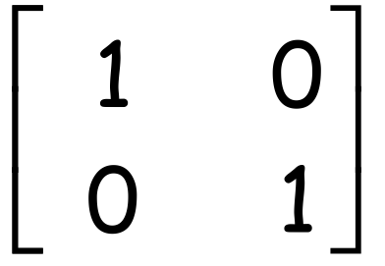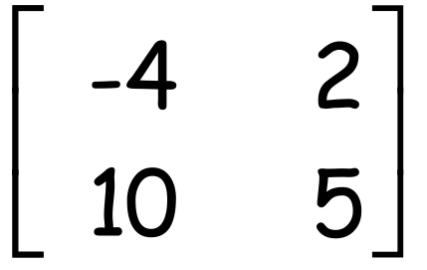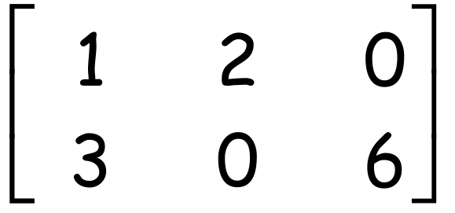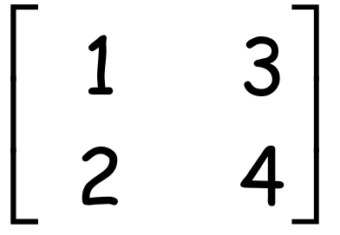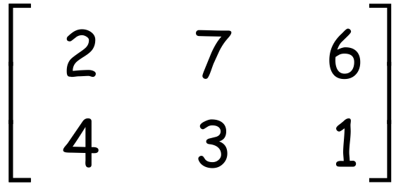
A = B = C = D = E =

- Give the value of c₂₃.

- Give the value of c₃₂.

- Calculate A + B

- Calculate B - D

- Calculate 2A

- Calculate 2A + C

- Give the dimensions of C

- What is the name given to the Matrix E

Question 2 [1, 1, 1, 1, 2 = 6 marks]
Give an answer of True or False for the following.
- A matrix of order 3x4 will have 34 elements.

- For the 2x2 matrices A and B
A + B = B + A

- For the 2x2 matrices A, B and C
(A + B) + C = A +( B + C)

- For the 2x2 matrices A and B
AxB = BxA

- For the 4x3 matrix A and the 3x5 matrix B
i) the dimensions of AxB are 4x5

ii) the dimensions of BxA are 3x3

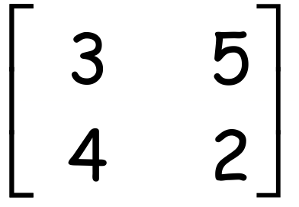Question 3 [ 5 marks]
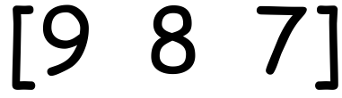If matrix A is given by A = and matrix B is given by B =

- Calculate A²

- Calculate B²

Question 4 [2, 2, 2, 1 = 7 marks]
Calculate the following products. If any are not possible give an explanation why.
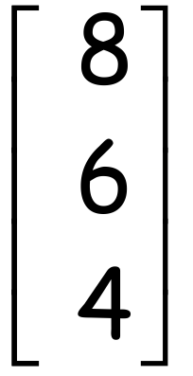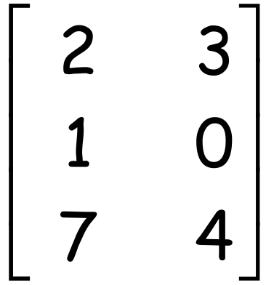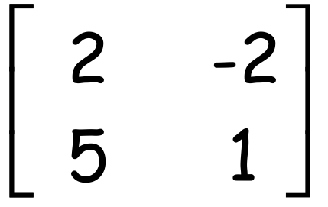
- 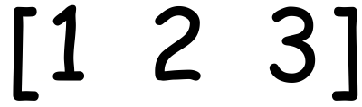 X b) X

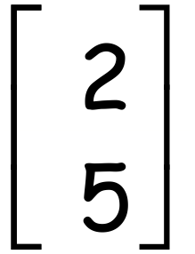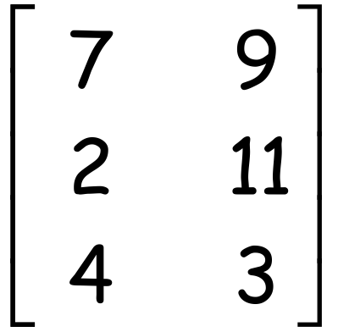
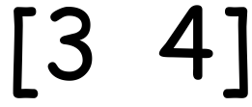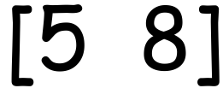 c) X d) X

Question 5 [3 marks]
For the 2x2 matrices A, B, C and D

- A + B = A if matrix B is a Matrix

- A x C = A if matrix C is a Matrix

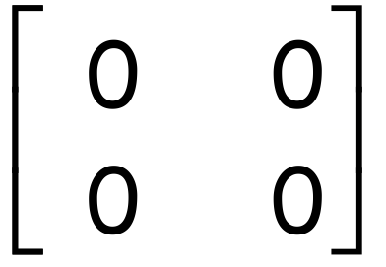
- A x D = if matrix D is a Matrix


MATHEMATICS APPLICATIONS
Test 5 2018
Matrices
Section B-Resource Assumed
Marks: 29 Time Allowed: 30 minutes

ALL working must be shown for full marks.
For any answers that do not exist an explanation must be given.
Question 1 [2, 1, 1, 1, 1, 3 = 9 marks]
- Construct a route matrix R for the following network showing Ben’s trip to school.
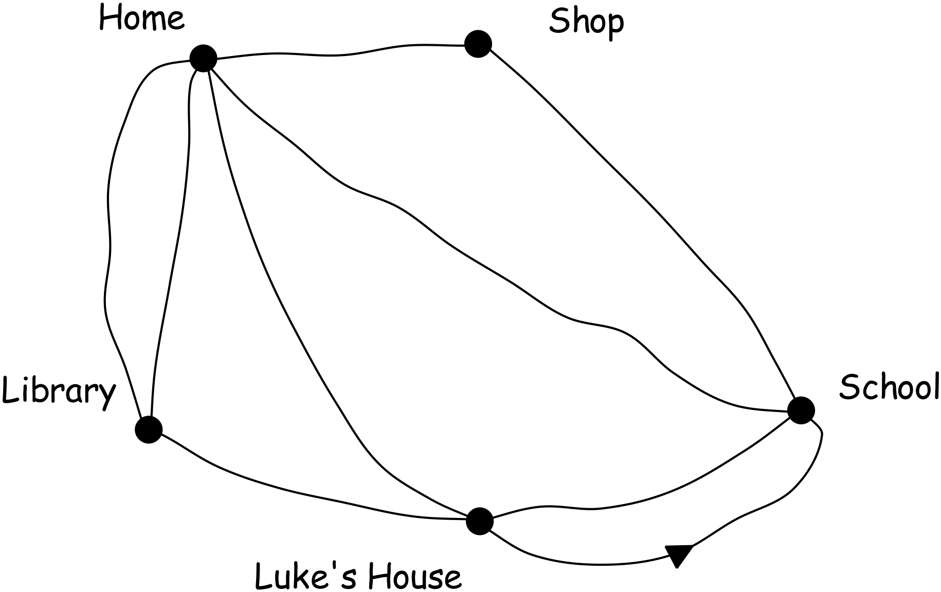To
H Sh Sc Li Lu
R = H

Sh

From Sc

Li

Lu

- The two stage route matrix can be obtained by doing what to the original route matrix?

- Give the two stage route matrix for Ben’s trip to school.

- How many ways can Ben get to school if he makes one stop on the way?

- How many ways can Ben get home from school if he makes one stop on the way?

- On the way home from school today Ben needs to make two stops.
i) What needs to be done to matrix R to show these paths?

ii) Show this matrix

iii) How many ways can Ben get home if he stops at Luke’s house and the library?

Question 2 [ 3, 4, 3 = 10 marks]
- Find the value of x and y if
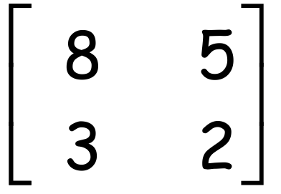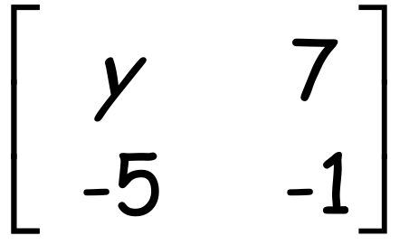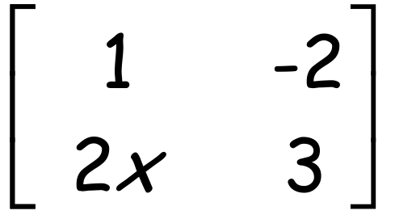
+ =

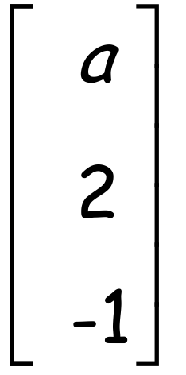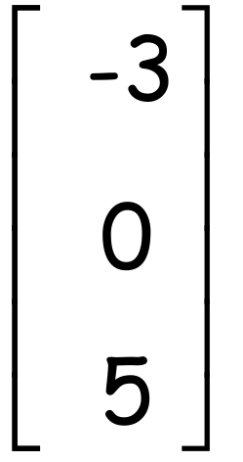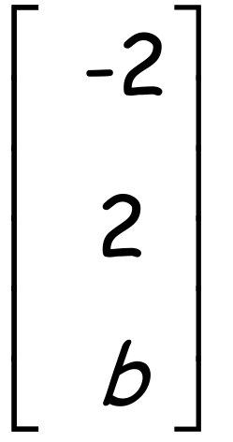
- Find the values of a and b if P = Q = R = and P + 2Q = R

- Find the values of m and n if
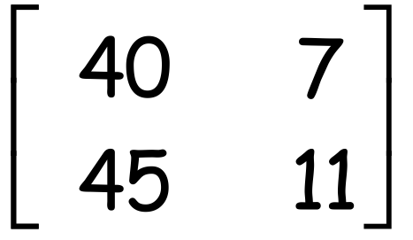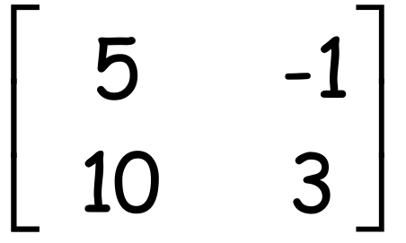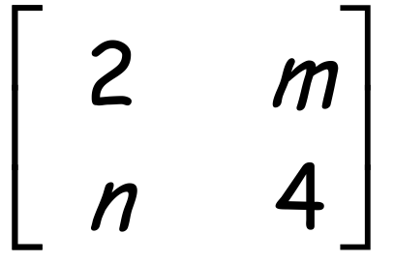
X =

Question 3 [2, 2 = 4 marks]
- If a_{mn} is the element situated in the m^{th} row and n^{th} column of a 2x4 matrix A.
Write down matrix A if a_{mn} = 4m-n.

- Matrix B has a square number of elements less than 65, but is not a square matrix. It is a rectangular matrix with 12 less columns than rows. What is the order of matrix B

Question 4 [1, 1, 3, 1 = 6 marks]
The table below shows the seat prices for three different seating areas of His Majesty’s Theatre Perth.
Ticket Cost | Grand Circle | Dress Circle | Stalls
Adult | $170 | $150 | $120
Concession | $155 | $130 | $90
- Represent this information as the 2x3
matrix C.

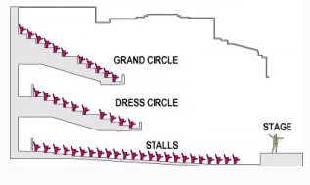

The number of tickets sold for the Saturday night performance is given in the table below.

Tickets sold | Adult | Concession
Grand Circle | 158 | 122
Dress Circle | 287 | 153
Stalls | 97 | 103
- Represent this information as the 3x2 matrix T.

- Give the matrix that will show the total money made on ticket sales for each section of the theatre.

- What is the money made on total ticket sales for the Saturday night?

